

RESTAURANT ORDERING & MANAGEMENT SYSTEM
(ROMS)

SOFTWARE DESIGN SPECIFICATION
SWP391 - Software Development Project

Academic Term: Fall 2026
Department: Software Engineering, FPT University Da Nang
Development Team: ROMS Team

- Da Nang, November 2026 -

Record of changeS
Date | A*M, D | In charge | Change Description
15/09/2026 | A | Team ROMS | Initial draft of Software Design Specification (SDS v1.0), core package structure, and database architecture.
05/10/2026 | M | Team ROMS | Updated Section I.2 Database Design with 14 physical tables, added audit and dining session fields.
20/10/2026 | A | Team ROMS | Added Section II Code Designs for Feature 1 (Auth), Feature 2 (Table QR Dining Session), and Feature 3 (Customer Batch Ordering).
02/11/2026 | A | Team ROMS | Added Code Designs for Feature 4 (Kitchen KDS Workflow) and Feature 5 (Cashier Billing & PayOS Payment Settlement).
11/11/2026 | M | Team ROMS | Completed full SDS v2.0 with all Class Diagrams, Class Specifications, Sequence Diagrams, and SQL Queries for final release.

*A - Added M - Modified D - Deleted

Table of Contents
I. Overview 5
1. Code Packages 5
2. Database Design 8
a. Database Schema 8
b. Table Description 9
3. Overall Domain Entity Class Diagram 11
II. Code Designs 12
1. Authentication & Role-Based Access Control (RBAC) 12
a. Class Diagram 12
b. Class Specifications 13
c. Sequence Diagram(s) 15
d. Database Queries 16
2. Table QR & Dining Session Management (Dining Gate) 16
a. Class Diagram 16
b. Class Specifications 17
c. Sequence Diagram(s) 19
d. Database Queries 20
3. Digital Menu & Customer Batch Ordering (QR Ordering) 20
a. Class Diagram 20
b. Class Specifications 21
c. Sequence Diagram(s) 23
d. Database Queries 24
4. Kitchen Display System (KDS) & Real-time Cooking Workflow 24
a. Class Diagram 25
b. Class Specifications 25
c. Sequence Diagram(s) 27
d. Database Queries 28
5. Cashier Billing & Financial Settlement (Payment & PayOS) 28
a. Class Diagram 28
b. Class Specifications 29
c. Sequence Diagram(s) 31
d. Database Queries 32
6. Table Reservation Management (Booking & Buffer Allocation) 33
a. Class Diagram 33
b. Class Specifications 33
c. Sequence Diagram(s) 34
d. Database Queries 35

I. Overview

1. Code Packages
The Restaurant Ordering & Management System (ROMS) is architected upon modern enterprise standards, separating concerns between a Spring Boot 3 RESTful Backend and a React 18 Modular Frontend. Communication is driven by HTTP REST APIs for standard CRUD operations and WebSocket STOMP protocol (over SockJS) for low-latency, bidirectional event synchronization between dining tables, the kitchen display terminal, waiter handhelds, and the cashier POS.
The backend implements a classic 3-Tier Layered Architecture with cross-cutting concerns handled by Spring Security and global AOP advice. The frontend is modularized into role-based views with shared atomic components and global state providers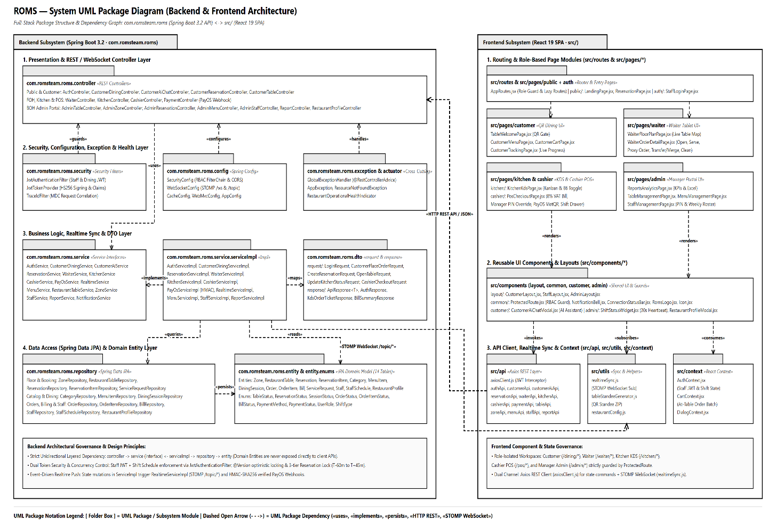

Figure 1: ROMS Full-Stack Architecture & Package Diagram
Technical Architecture Explanation:
- Presentation / Controller Layer: Receives incoming HTTP requests from React client and external webhooks (e.g. PayOS). Responsible for parameter extraction, request payload validation (@Valid), and returning standardized JSON responses encapsulated in ApiResponse<T>. It delegates all business rules to the service layer without containing transactional logic.
- Business Logic / Service Layer: Contains the core business rules, transactional boundaries (@Transactional), price and subtotal calculations, manual inventory stock assertions, and real-time WebSocket event dispatching. Exposed as Java Interfaces with corresponding ServiceImpl classes to support dependency inversion and mock unit testing.
- Data Access / Persistence Layer: Spring Data JPA repositories extending JpaRepository and JpaSpecificationExecutor. Manages database entity persistence, custom JPQL queries, and pessimistic locking queries (SELECT ... FOR UPDATE) during high-concurrency cart checkouts.
- Entity Domain Layer: JPA domain models mapping directly to the 14 relational tables in MySQL 8.0, maintaining object relationships, bidirectional associations (@OneToMany, @ManyToOne), and temporal auditing timestamps.
- Security & Infrastructure: Stateless JWT token authentication, BCrypt password hashing, role-based authorization (ADMIN, CASHIER, WAITER, CHEF), and CORS filters for frontend access.
- Frontend Modular Structure: Component-based single-page application (SPA) featuring atomic components, React Router v6 guards, and centralized Axios interceptors for automated JWT injection and error trapping.
Package & Class Naming Conventions:
- Java Packages: All package names must be written in lowercase characters following reverse domain naming conventions: com.romsteam.roms.<layer>.
- Java Classes: Written in UpperCamelCase (PascalCase) with meaningful suffix reflecting their architectural layer: *Controller, *Service, *ServiceImpl, *Repository, *Entity, *Request, *Response, *Config.
- Java Interfaces: Written in UpperCamelCase without Hungarian prefixes (e.g., AuthService, MenuItemRepository).
- Java Methods: Written in lowerCamelCase starting with an active verb describing the operation: placeBatchOrder(), processCashPayment(), findActiveSessionByTableId().
- Java Constants: Written in uppercase letters with underscore separators: ORDER_STATUS_PENDING, MAX_RESERVATION_BUFFER_MINUTES.
- Frontend Components: PascalCase for React components (*.jsx) and camelCase for hooks (useWebSocket.js) and utility functions (formatCurrency.js).
Table 1: ROMS Package & Directory Architecture Descriptions
No | Subsystem | Package / Folder | Description
01 | Backend | com.romsteam.roms.controller | REST API controllers exposing secured endpoints for Customer, Waiter, Cashier, Kitchen, and Admin.
02 | Backend | com.romsteam.roms.service | Business logic interfaces declaring domain contracts, workflows, and transaction boundaries.
03 | Backend | com.romsteam.roms.service.serviceImpl | Concrete implementations executing business rules, validations, inventory deductions, and WebSocket dispatches.
04 | Backend | com.romsteam.roms.repository | Spring Data JPA data access interfaces providing CRUD operations and custom native/JPQL queries.
05 | Backend | com.romsteam.roms.entity | Domain entities mapped to the 14 MySQL tables with Hibernate annotations and relationship mappings.
06 | Backend | com.romsteam.roms.dto.request | Inbound request DTOs with Jakarta Bean Validation annotations (@NotNull, @Min, @NotBlank).
07 | Backend | com.romsteam.roms.dto.response | Standardized outbound response payload objects wrapped in generic ApiResponse<T> containers.
08 | Backend | com.romsteam.roms.security | Spring Security configuration, JWT authentication filter, UserDetailsService, and password encoders.
09 | Backend | com.romsteam.roms.config | Global system configurations: CORS policy, WebSocket STOMP message broker, Swagger/OpenAPI, PayOS client.
10 | Backend | com.romsteam.roms.exception | Centralized error handling via @ControllerAdvice and custom domain exceptions (ResourceNotFound, BadRequest).
11 | Frontend | src/pages | Top-level view screens organized by actor role (Customer Dining, Waiter POS, Kitchen KDS, Cashier, Admin).
12 | Frontend | src/components | Reusable atomic UI components including TableCard, MenuItemCard, CartDrawer, Modals, and StatsCard.
13 | Frontend | src/api | Centralized Axios HTTP client instances with request/response interceptors for automatic JWT injection.
14 | Frontend | src/context | React Context state providers managing AuthContext, CartContext, TableContext, and SocketContext.
15 | Frontend | src/routes | React Router routing definitions with ProtectedRoute wrappers enforcing role-based client guards.
16 | Frontend | src/utils | Helper utilities for currency formatting (VND), QR payload decryption, and date-time conversions.

2. Database Design

a. Database Schema
The ROMS database is engineered on MySQL 8.0 Community Server utilizing the InnoDB storage engine to guarantee full ACID transaction compliance. The physical relational schema consists of 14 normalized tables designed in 3rd Normal Form (3NF) to eliminate data redundancy while maintaining referential integrity.
Key relational characteristics include:
- Foreign Key Constraints: Enforced on master tables (e.g., categories cannot be deleted while active menu_items reference them; dining_sessions cannot be purged while active orders exist) to prevent orphaned transactions and maintain financial auditability.
- Performance Indexing: Configured on all primary keys (B-Tree index) and foreign keys (dining_session_id, order_id, table_id, category_id) to accelerate join operations and optimize high-throughput point queries.
- Concurrency Controls: Pessimistic write locking (SELECT ... FOR UPDATE) is applied on menu_items.stock_quantity during concurrent order placements to eliminate race conditions and overselling.
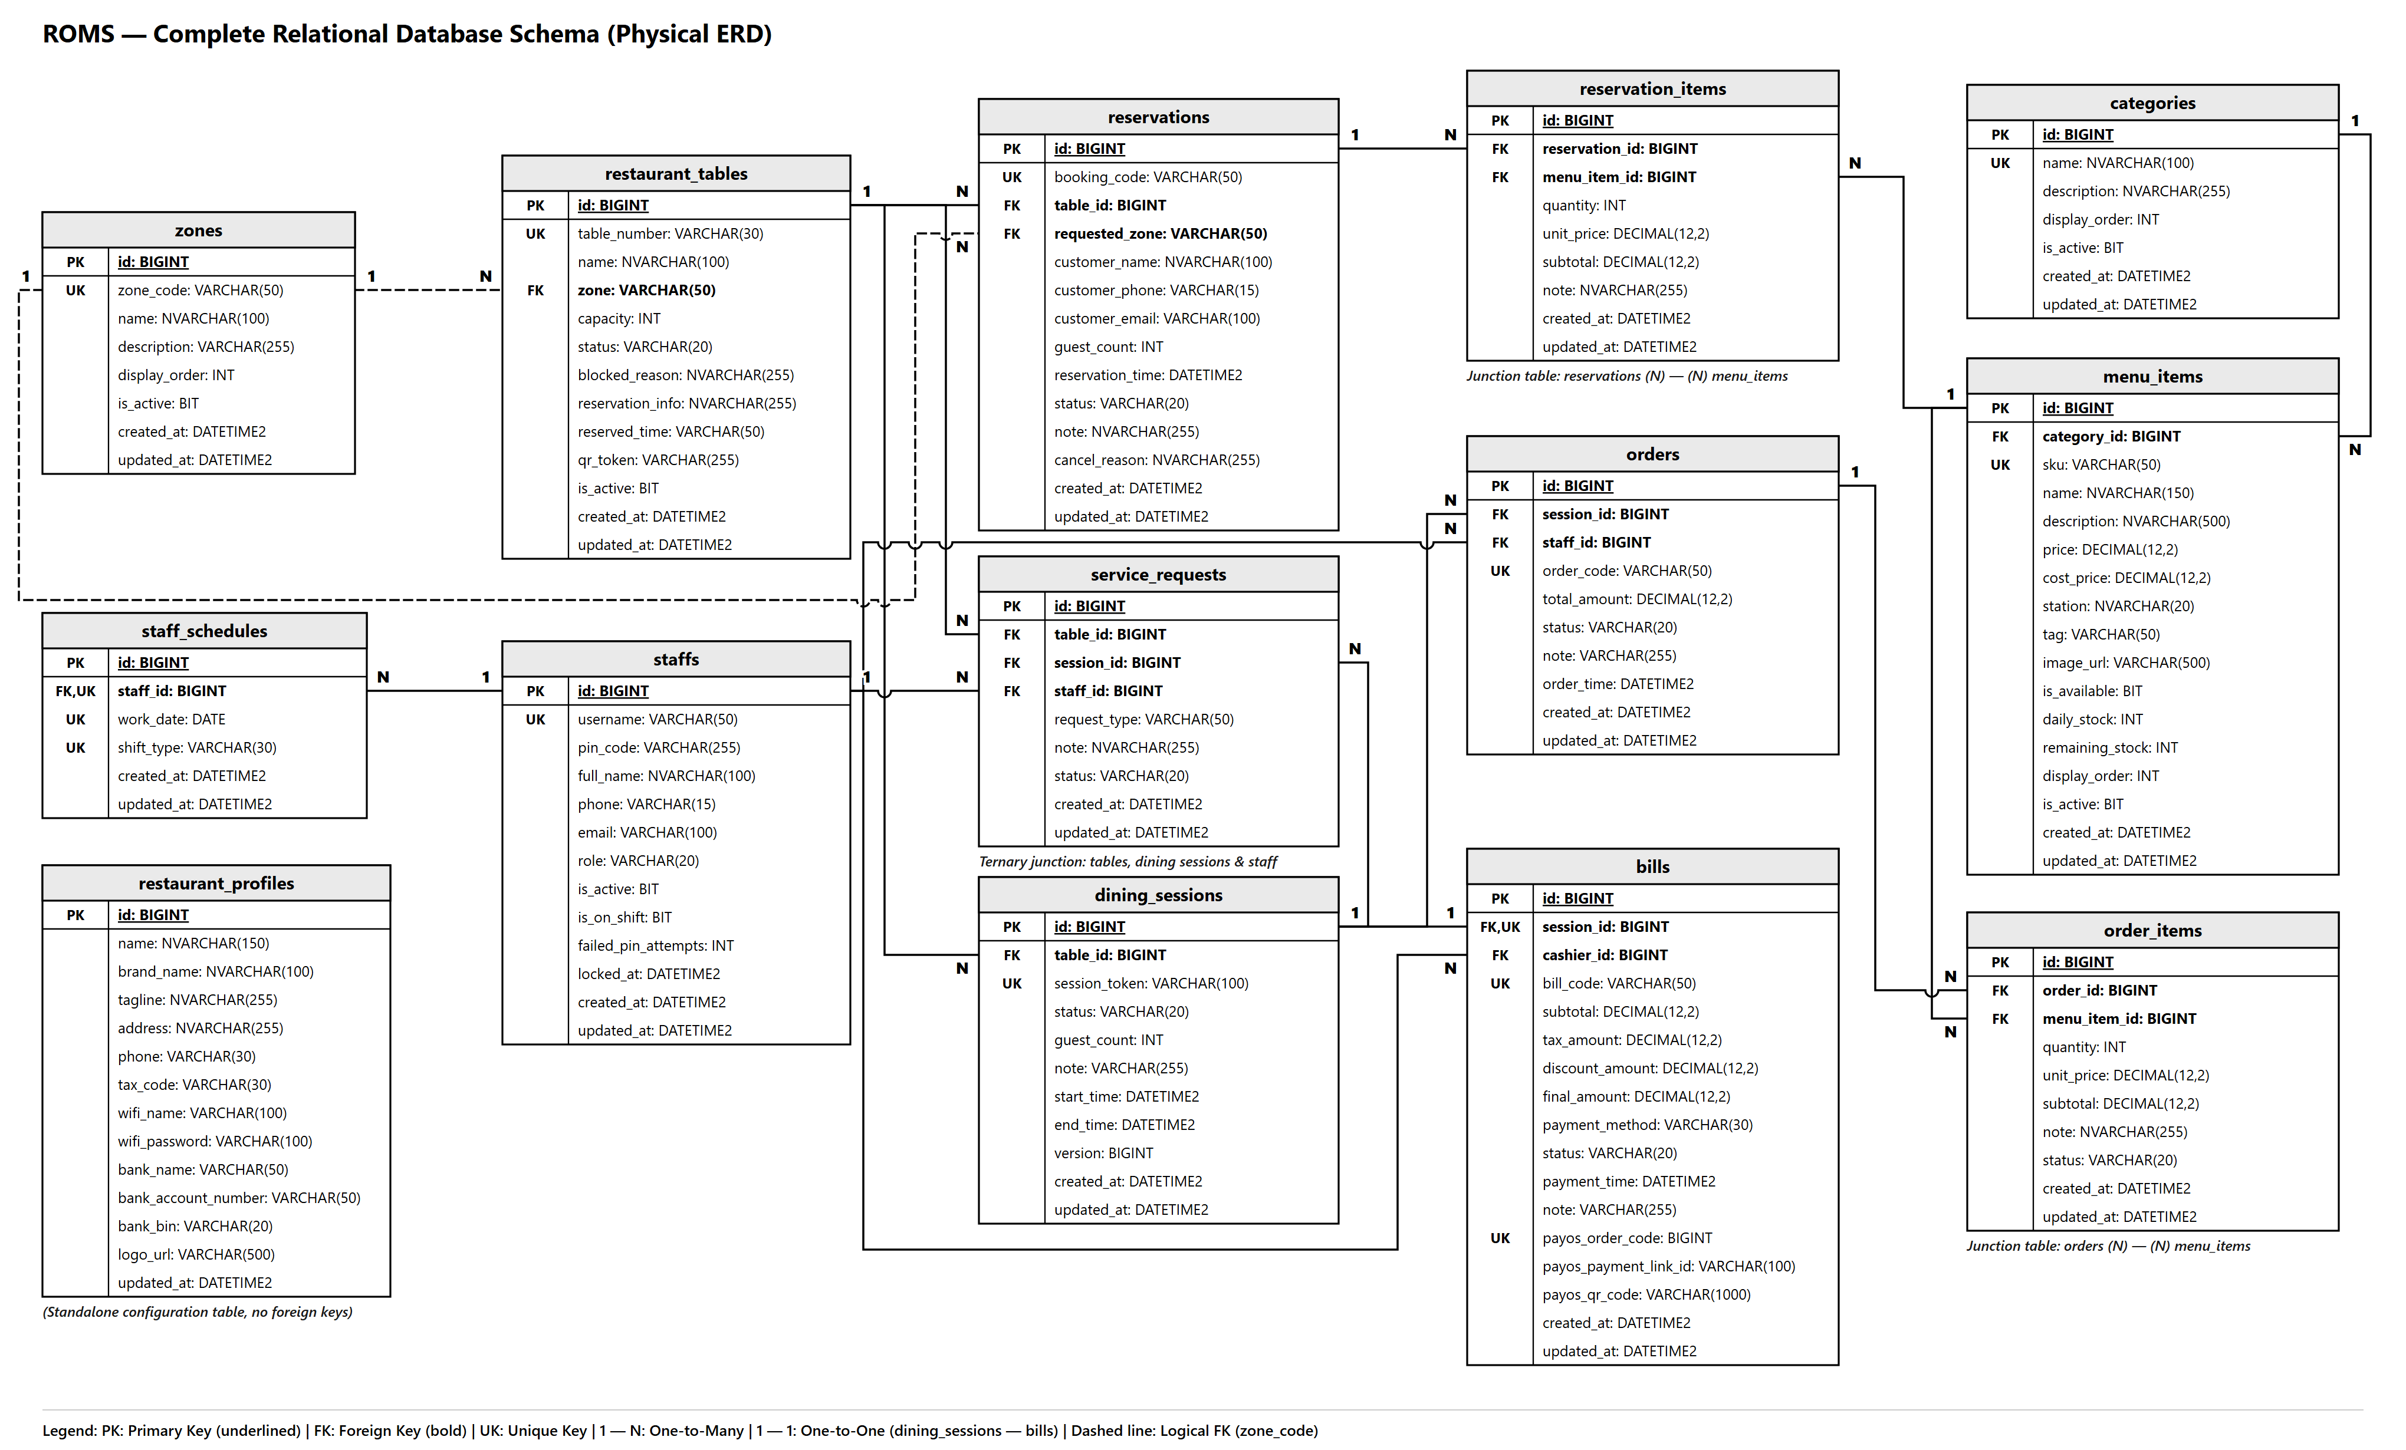
Figure 2: ROMS Physical Database Relational Schema (14 Tables)

b. Table Description
Table 2: ROMS Database Entity & Table Descriptions
No | Table Name | Description
01 | staff | Stores internal restaurant employee accounts, encrypted passwords (BCrypt), role assignment (ADMIN, MANAGER, CASHIER, WAITER, CHEF), and employment status.
02 | restaurant_tables | Manages physical dining tables, seat capacities, assigned zone layout references, and operational statuses (AVAILABLE, OCCUPIED, RESERVED).
03 | dining_sessions | Tracks in-store customer dining sessions, dynamic QR security tokens, check-in and checkout timestamps, and active session states.
04 | categories | Categorizes food and beverage items (Appetizers, Main Dishes, Drinks, Desserts) for structured catalog browsing.
05 | menu_items | Defines all dishes, pricing, promotional tags, preparation flags, image URLs, active status, and manual stock tracking counters.
06 | orders | Records individual batch orders placed by customers or staff during an active dining session, including timestamp and batch total.
07 | order_items | Contains line-item details of each order: item reference, quantity, unit price at ordering time, special instructions, and KDS status (PENDING, COOKING, DONE, SERVED, CANCELLED).
08 | bills | Final invoices generated upon checkout: subtotal amount, applied discounts, VAT taxes, settlement status (PAID, REFUNDED), payment method (CASH, PAYOS_QR), and cashier association.
09 | reservations | Stores advance table reservation requests from customers: guest contact info, party size, requested timeslot, deposit status, and booking status (PENDING, CONFIRMED, COMPLETED, CANCELLED).
10 | reservation_items | Pre-selected dishes attached to advance reservations, facilitating upfront meal preparation and deposit calculations.
11 | zones | Defines restaurant floor areas / layout zones (Indoor Ground, Second Floor, Outdoor Garden, VIP Rooms) for spatial organization.
12 | service_requests | Real-time assistance requests raised by in-dining customers (Call Waiter, Water Refill, Bill Request) dispatched to staff terminals.
13 | staff_schedules | Work shift assignments mapping staff members to designated time slots and operational duty roles.
14 | restaurant_profiles | Core restaurant configuration parameters (Brand name, address, tax code, operating hours, banking credentials for automated QR payment).

3. Overall Domain Entity Class Diagram
The Domain Model illustrates the structural classes and relationships that constitute the core business entities of the ROMS restaurant ordering platform. Designed according to strict monochrome UML conventions, it details entity attributes, methods, and multiplicities (1..*, 1..1, 0..*) governing restaurant operations:
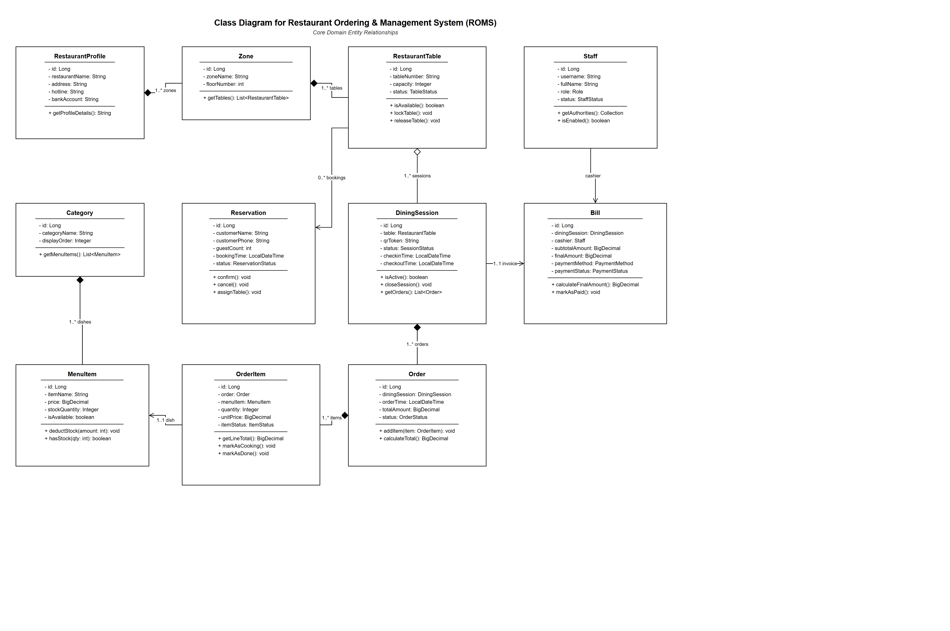
Figure 3: ROMS Core Domain Entity Class Diagram (Monochrome UML)

II. Code Designs

1. Authentication & Role-Based Access Control (RBAC)
This feature governs internal restaurant security, verifying employee credentials through cryptographic hash comparison (BCrypt) and issuing stateless, cryptographically signed JSON Web Tokens (JWT). The issued token embeds user claims including staff ID and Role (ADMIN, CASHIER, WAITER, CHEF), enabling fine-grained, method-level authorization across all subsystem endpoints.

a. Class Diagram
The authentication subsystem is composed of presentation controllers, service contracts, Spring Security integration components, and entity repositories:
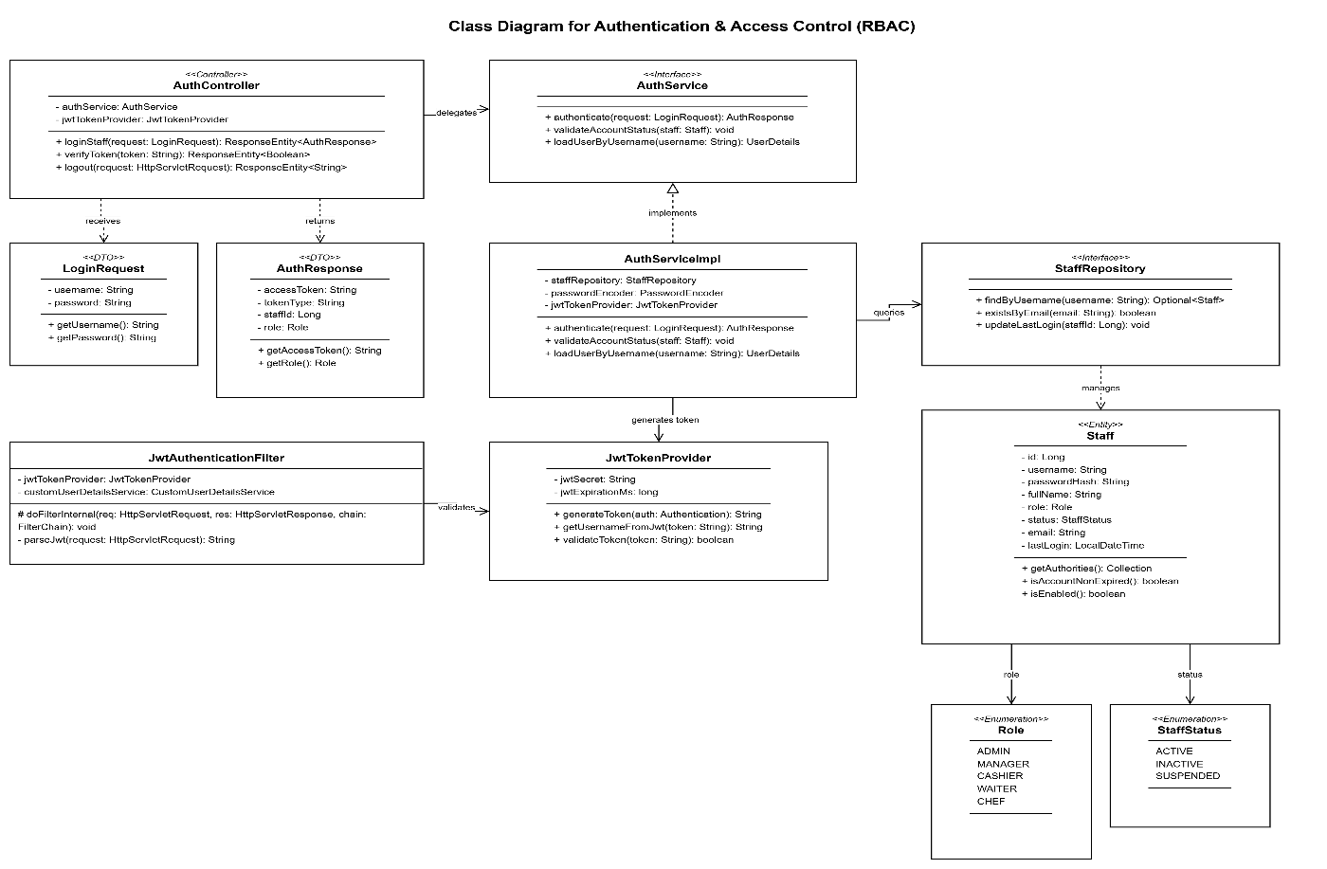
Figure 4: Class Diagram for Staff Authentication & RBAC Access Control
- AuthController: Handles incoming authentication requests via POST /api/auth/login and token validation queries.
- AuthService: Declares the authentication contract and account verification methods.
- AuthServiceImpl: Implements credential verification, status checks, and token issuing logic.
- StaffRepository: Spring Data JPA repository retrieving staff records by username or email.
- Staff (Entity): Domain model encapsulating employee data, hashed credentials, and role enums.
- JwtTokenProvider: Utility component responsible for HMAC-SHA256 signature generation, claim parsing, and expiration validation.
- JwtAuthenticationFilter: Per-request filter intercepting HTTP calls to extract and validate Bearer tokens from the Authorization header.

b. Class Specifications

AuthController Class
Class Methods: AuthController
No | Method | Description
01 | loginStaff(@Valid @RequestBody LoginRequest request) | Input: LoginRequest (username, password).  Output: ResponseEntity<ApiResponse<AuthResponse>> containing JWT and profile.  Internal Processing: Validates input syntax -> delegates to AuthService.authenticate() -> returns HTTP 200 OK with signed JWT.
02 | verifyToken(@RequestHeader String token) | Input: String Authorization Bearer token.  Output: ResponseEntity<ApiResponse<Boolean>>.  Internal Processing: Invokes JwtTokenProvider.validateToken() -> returns boolean validity status.
03 | logout(HttpServletRequest request) | Input: HttpServletRequest.  Output: ResponseEntity<ApiResponse<String>>.  Internal Processing: Clears SecurityContextHolder authentication -> returns success confirmation.

AuthServiceImpl Class
Class Methods: AuthServiceImpl
No | Method | Description
01 | authenticate(LoginRequest request) | Input: LoginRequest DTO.  Output: AuthResponse DTO.  Internal Processing: 1. Queries StaffRepository by username. 2. Throws BadCredentialsException if user not found. 3. Verifies BCrypt password hash. 4. Asserts staff status is ACTIVE. 5. Calls JwtTokenProvider to generate token. 6. Updates last_login timestamp. 7. Constructs and returns AuthResponse.
02 | validateAccountStatus(Staff staff) | Input: Staff entity.  Output: void.  Internal Processing: Checks if staff.getStatus() == StaffStatus.ACTIVE. If INACTIVE or TERMINATED, throws AccountDisabledException.
03 | loadUserByUsername(String username) | Input: String username.  Output: UserDetails.  Internal Processing: Implements Spring Security contract -> constructs UserPrincipal with GrantedAuthority mapped from staff.getRole().

c. Sequence Diagram(s)
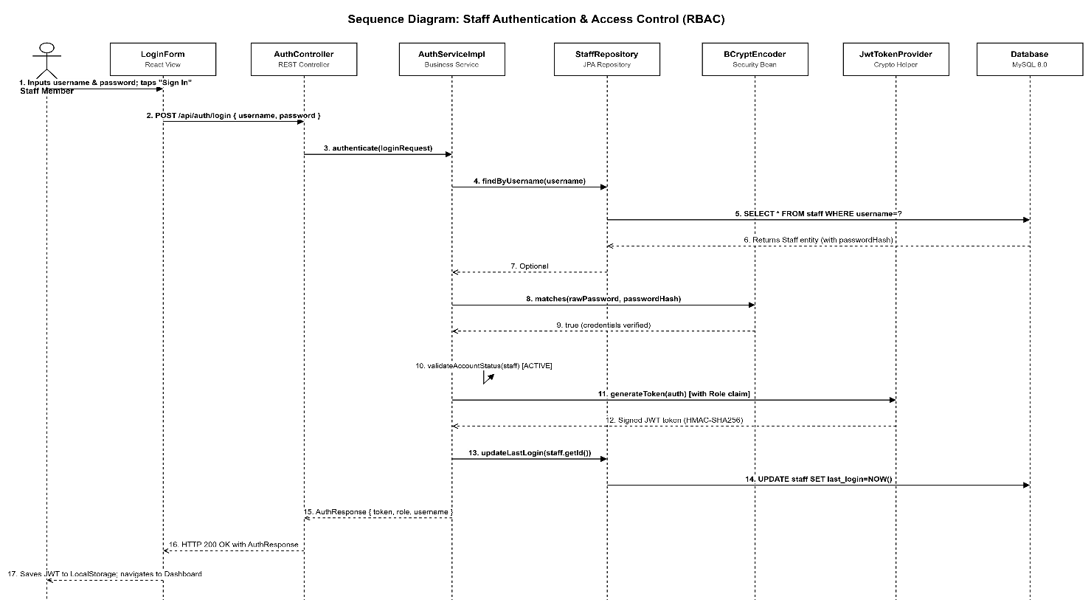
Figure 5: Sequence Diagram for Staff Authentication & Access Control
The authentication workflow proceeds through the following sequential interactions:
- Step 1: Staff enters username and password on the staff login portal and submits the form.
- Step 2: React frontend sends POST /api/auth/login with JSON body containing credentials to AuthController.
- Step 3: AuthController validates payload and calls AuthServiceImpl.authenticate(request).
- Step 4: AuthServiceImpl queries StaffRepository.findByUsername(username). Database returns Staff record.
- Step 5: AuthServiceImpl invokes BCryptPasswordEncoder.matches(rawPassword, encodedPassword). If mismatch, throws 401 Unauthorized.
- Step 6: AuthServiceImpl verifies staff status is ACTIVE. If disabled, throws 403 Forbidden.
- Step 7: AuthServiceImpl invokes JwtTokenProvider.generateToken(authentication) to generate signed JWT string embedding role claim.
- Step 8: StaffRepository updates last_login timestamp in staff table.
- Step 9: AuthController wraps token and user profile into ApiResponse and returns HTTP 200 to frontend.
- Step 10: Frontend saves JWT to LocalStorage and initializes AuthContext with user role claims.

d. Database Queries
The following SQL queries are executed during authentication:
-- 1. Query staff account by username
SELECT id, username, password_hash, full_name, role, status, email, phone, last_login
FROM staff
WHERE username = ? AND status = 'ACTIVE'
LIMIT 1;

-- 2. Update last login timestamp upon successful verification
UPDATE staff
SET last_login = NOW()
WHERE id = ?;

2. Table QR & Dining Session Management (Dining Gate)
This feature manages the lifecycle of physical restaurant tables and controls customer dining authorization through dynamic QR codes. It implements a strict Dining Gate mechanism: when a customer scans a table QR code, the system validates whether the table is active and occupied. If a dining session is open, access is granted; if closed or locked, ordering is strictly gated.

a. Class Diagram
The dining session subsystem classes and relationships:
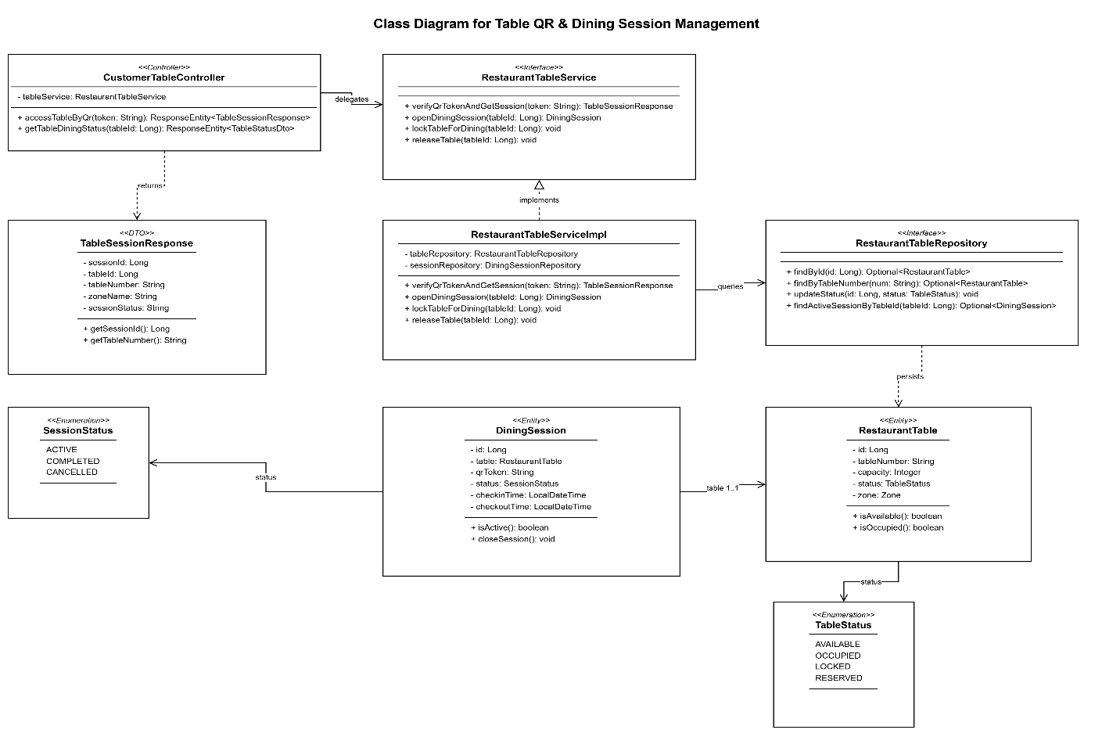
Figure 6: Class Diagram for Table QR & Dining Session Management
- CustomerTableController: Public endpoints for QR token verification and customer table status queries.
- RestaurantTableService: Declares session lifecycle rules (open, lock, close, verify).
- RestaurantTableServiceImpl: Executes QR token decoding, session state transitions, and concurrency checks.
- RestaurantTableRepository: JPA repository for physical tables with status queries.
- DiningSessionRepository: JPA repository for managing session records and token lookups.
- RestaurantTable (Entity): Physical table model with capacity, zone reference, and operational status.
- DiningSession (Entity): Session model linking table, customer party, dynamic QR token, and start/checkout timestamps.

b. Class Specifications

CustomerTableController Class
Class Methods: CustomerTableController
No | Method | Description
01 | accessTableByQr(@RequestParam String token) | Input: String cryptographic QR token from URL.  Output: ResponseEntity<ApiResponse<TableSessionResponse>>.  Internal Processing: Invokes RestaurantTableService.verifyQrTokenAndGetSession() -> returns table info and active session details.
02 | getTableDiningStatus(@PathVariable Long tableId) | Input: Long tableId.  Output: ResponseEntity<ApiResponse<TableStatusDto>>.  Internal Processing: Queries table status and active dining session -> returns current state (AVAILABLE, OCCUPIED, LOCKED).

RestaurantTableServiceImpl Class
Class Methods: RestaurantTableServiceImpl
No | Method | Description
01 | verifyQrTokenAndGetSession(String token) | Input: String QR token.  Output: TableSessionResponse DTO.  Internal Processing: 1. Looks up DiningSession by token in DiningSessionRepository. 2. If no active session found, checks if table is AVAILABLE and opens a new session. 3. If session status is COMPLETED or table is LOCKED, returns gate error. 4. Returns validated session payload.
02 | openDiningSession(Long tableId) | Input: Long tableId.  Output: DiningSession entity.  Internal Processing: 1. Retrieves table record. 2. Generates dynamic UUID token. 3. Persists new DiningSession with status = ACTIVE. 4. Updates table status to OCCUPIED. 5. Broadcasts table state change via WebSocket.
03 | lockTableForDining(Long tableId) | Input: Long tableId.  Output: void.  Internal Processing: Sets table operational status to LOCKED -> prevents customer order placement during checkout preparation.

c. Sequence Diagram(s)
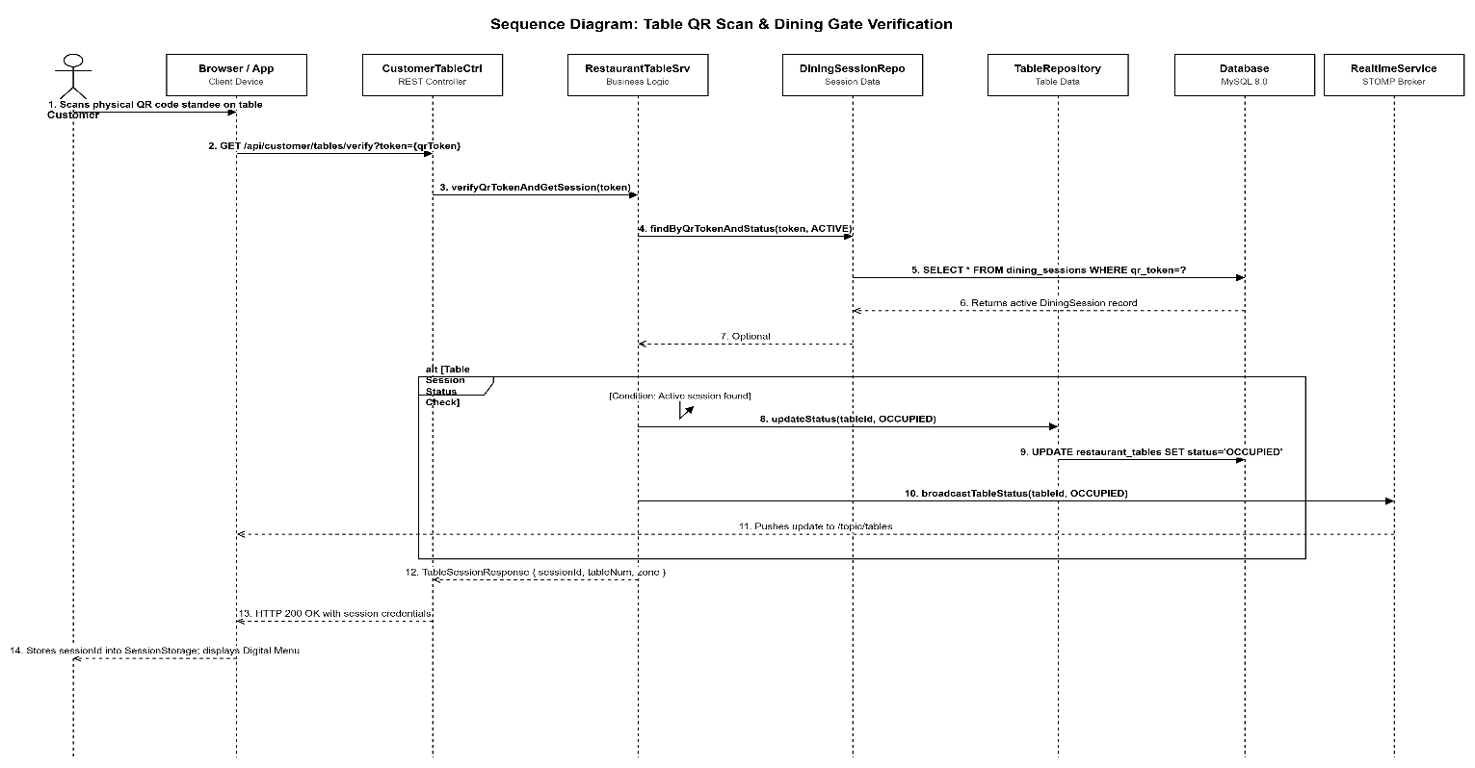
Figure 7: Sequence Diagram for Customer Table QR Access & Dining Gate Verification
Dining Gate Verification Sequence:
- Step 1: Customer scans QR code on dining table with smartphone camera and opens browser landing URL.
- Step 2: Client application extracts token from query parameter and calls GET /api/customer/tables/verify?token=... to CustomerTableController.
- Step 3: Controller delegates to RestaurantTableServiceImpl.verifyQrTokenAndGetSession(token).
- Step 4: Service queries DiningSessionRepository.findByQrTokenAndStatus(token, ACTIVE).
- Step 5: If active session exists, service returns active session ID, table number, and zone info.
- Step 6: If table is closed/unopened, service returns HTTP 403 Forbidden with code TABLE_UNOPENED, causing frontend to display gate holding screen.
- Step 7: Upon successful verification, frontend stores diningSessionId into SessionStorage and redirects guest to digital menu catalog.

d. Database Queries
-- 1. Query table and active dining session by QR token
SELECT ds.id AS session_id, ds.table_id, ds.qr_token, ds.status AS session_status,
t.table_number, t.capacity, t.status AS table_status, z.zone_name
FROM dining_sessions ds
JOIN restaurant_tables t ON ds.table_id = t.id
JOIN zones z ON t.zone_id = z.id
WHERE ds.qr_token = ? AND ds.status = 'ACTIVE'
LIMIT 1;

-- 2. Open new dining session for a table
INSERT INTO dining_sessions (table_id, qr_token, status, created_at)
VALUES (?, UUID(), 'ACTIVE', NOW());

-- 3. Transition physical table status to OCCUPIED
UPDATE restaurant_tables
SET status = 'OCCUPIED'
WHERE id = ?;

3. Digital Menu & Customer Batch Ordering (QR Ordering)
This feature is the primary customer revenue driver. It enables in-dining guests to browse categories, filter available items, accumulate dishes into a synchronized digital cart, and submit batch orders. The backend executes transactional inventory checks using pessimistic row locking, creates the Order and OrderItem records, and instantly broadcasts the batch to the Kitchen Display System via WebSocket.

a. Class Diagram
Core classes involved in the batch ordering workflow:
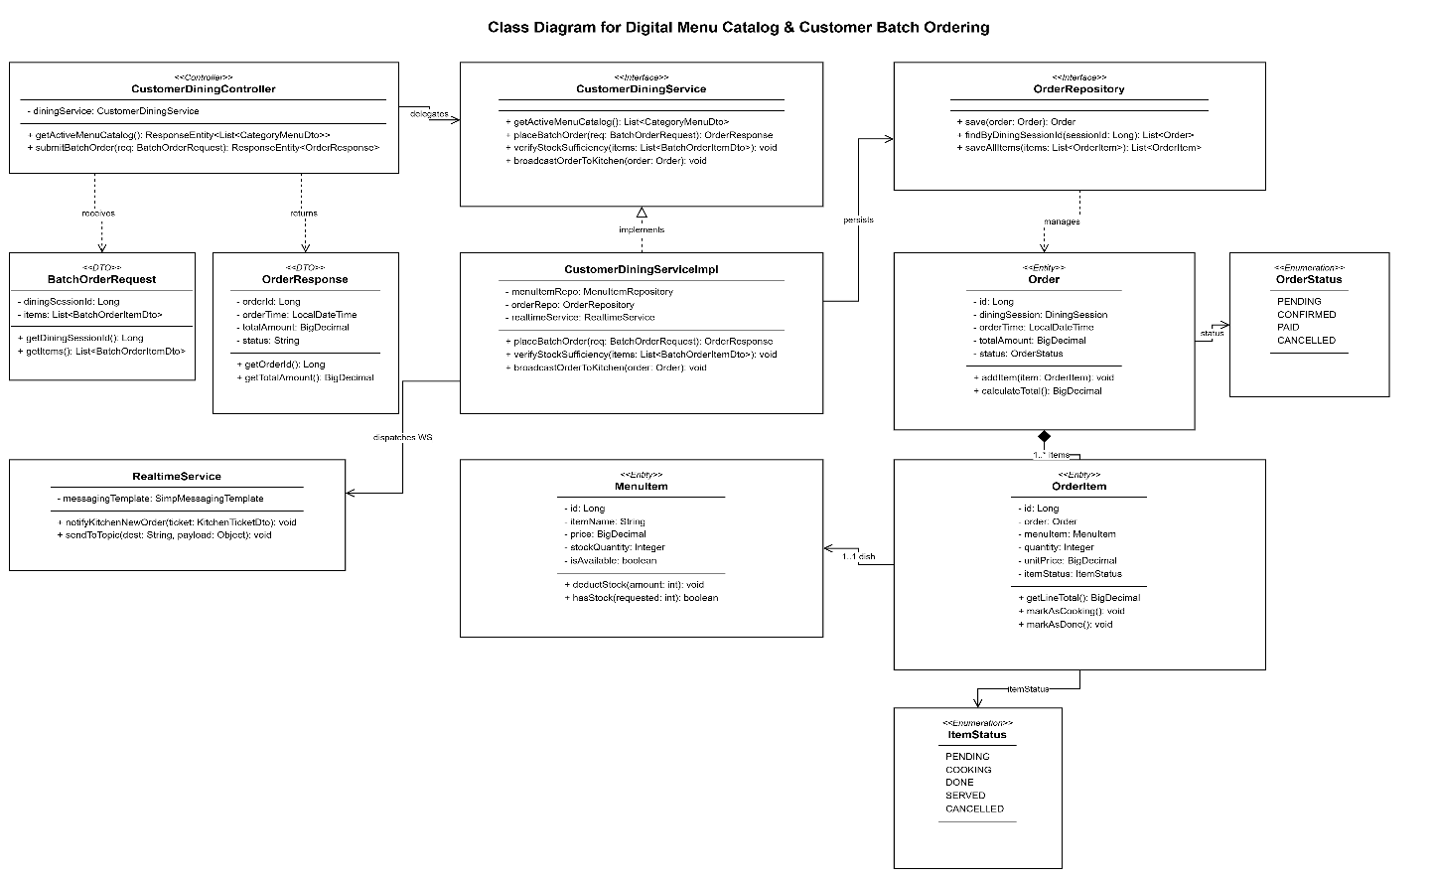
Figure 8: Class Diagram for Digital Menu Catalog & Customer Batch Ordering
- CustomerDiningController: Exposes menu retrieval and batch order placement endpoints for customers.
- CustomerDiningService: Declares contracts for menu rendering, cart validation, and order submission.
- CustomerDiningServiceImpl: Transactional business engine validating session status, row-locking stock quantities, creating orders, and dispatching events.
- MenuItemRepository: JPA repository for dish lookups, category joins, and pessimistic write lock queries.
- OrderRepository: JPA repository for order batch persistence.
- OrderItemRepository: JPA repository for line-item persistence and KDS status tracking.
- RealtimeService: Helper component publishing STOMP messages to /topic/kitchen and /topic/waiter.

b. Class Specifications

CustomerDiningController Class
Class Methods: CustomerDiningController
No | Method | Description
01 | getActiveMenuCatalog() | Input: None.  Output: ResponseEntity<ApiResponse<List<CategoryMenuDto>>>.  Internal Processing: Invokes CustomerDiningService.getMenuCatalog() -> returns available items grouped by category.
02 | submitBatchOrder(@RequestBody @Valid BatchOrderRequest request) | Input: BatchOrderRequest DTO containing diningSessionId and list of ordered items.  Output: ResponseEntity<ApiResponse<OrderResponse>>.  Internal Processing: Validates request payload -> calls CustomerDiningService.placeBatchOrder(request) -> returns HTTP 201 Created with saved order summary.

CustomerDiningServiceImpl Class
Class Methods: CustomerDiningServiceImpl
No | Method | Description
01 | placeBatchOrder(BatchOrderRequest request) | Input: BatchOrderRequest DTO.  Output: OrderResponse DTO.  Internal Processing: 1. Asserts dining session exists and status is ACTIVE. 2. For each requested item, executes MenuItemRepository.findStockByIdForUpdate() with pessimistic write lock. 3. Validates stock_quantity >= requested quantity. Throws OutOfStockException if insufficient. 4. Calculates batch subtotal. 5. Creates Order entity (status = PENDING). 6. Creates OrderItem entities with item price snapshot. 7. Decrements menu_item.stock_quantity. 8. Calls RealtimeService to broadcast order to /topic/kitchen. 9. Returns OrderResponse.
02 | verifyItemStockAndAvailability(List<BatchOrderItemDto> items) | Input: List of order items.  Output: void.  Internal Processing: Validates item is_available == true and stock sufficiency.
03 | broadcastOrderToKitchen(Order savedOrder) | Input: Order entity.  Output: void.  Internal Processing: Maps order and line items to KitchenTicketDto and sends via SimpMessagingTemplate to /topic/kitchen.

c. Sequence Diagram(s)
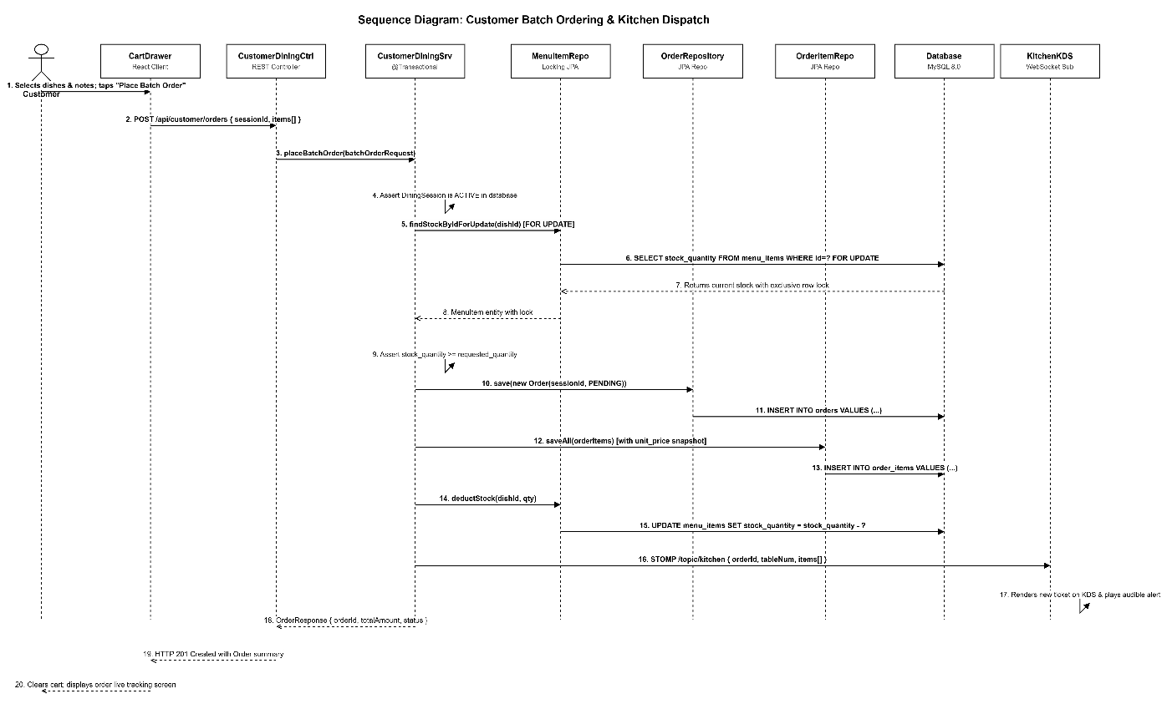
Figure 9: Sequence Diagram for Customer Batch Ordering & Real-time Kitchen Dispatch
Batch Ordering Execution Steps:
- Step 1: Customer selects items in digital cart and taps "Place Order" button.
- Step 2: Frontend sends POST /api/customer/orders with JSON payload to CustomerDiningController.
- Step 3: Controller initiates @Transactional service method placeBatchOrder(request).
- Step 4: Service acquires pessimistic write lock (FOR UPDATE) on each menu item in MySQL to ensure atomicity.
- Step 5: Service verifies current stock levels; throws error if item sold out during checkout.
- Step 6: Service persists master Order record and line-item OrderItem records into MySQL.
- Step 7: Service decrements stock_quantity on menu_items table.
- Step 8: Service dispatches STOMP message to /topic/kitchen via RealtimeService.
- Step 9: Kitchen display terminal receives live WebSocket message and plays audible alert.
- Step 10: Controller returns HTTP 201 Created and customer UI clears shopping cart.

d. Database Queries
-- 1. Pessimistic write lock query to prevent race conditions on stock
SELECT id, item_name, price, stock_quantity, is_available
FROM menu_items
WHERE id = ? FOR UPDATE;

-- 2. Insert new order batch record
INSERT INTO orders (dining_session_id, order_time, total_amount, status)
VALUES (?, NOW(), ?, 'PENDING');

-- 3. Insert line items into order_items table
INSERT INTO order_items (order_id, menu_item_id, quantity, unit_price, notes, item_status, created_at)
VALUES (?, ?, ?, ?, ?, 'PENDING', NOW());

-- 4. Deduct inventory stock quantity
UPDATE menu_items
SET stock_quantity = stock_quantity - ?
WHERE id = ?;

4. Kitchen Display System (KDS) & Real-time Cooking Workflow
The Kitchen Display System replaces traditional paper kitchen chits with digital touchscreens. It visualizes pending tickets in a First-In-First-Out (FIFO) queue, tracks item cooking states across an explicit state machine (PENDING -> COOKING -> DONE -> SERVED), and dispatches real-time alerts to floor staff when dishes are ready for pickup.

a. Class Diagram
KDS subsystem classes and component structure:
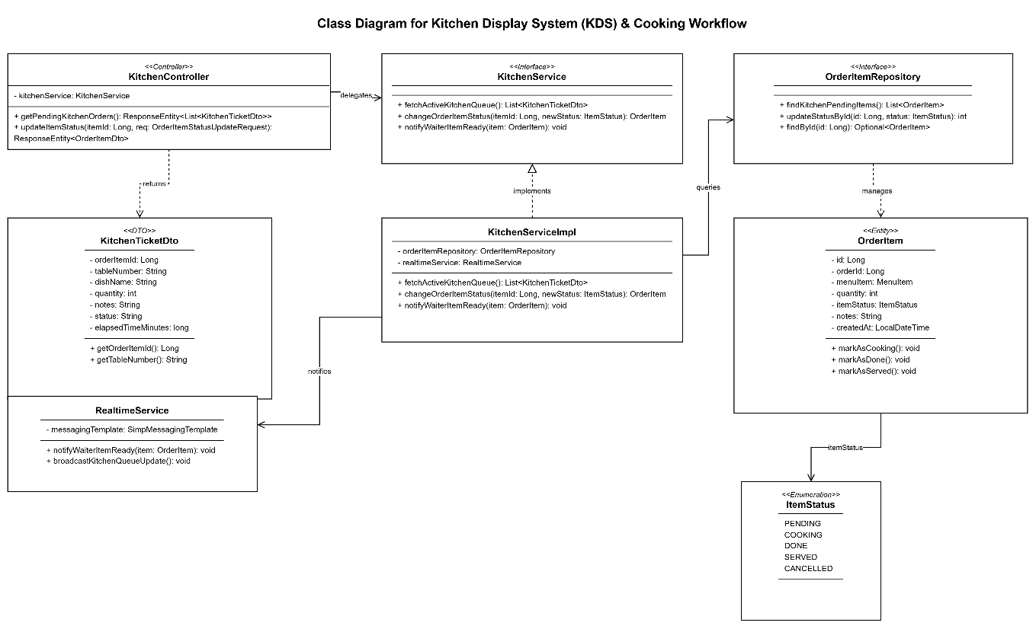
Figure 10: Class Diagram for Kitchen Display System (KDS) & Cooking Workflow
- KitchenController: Endpoints for chef interaction (fetching pending queue, updating dish status).
- KitchenService: Service contract defining kitchen ticket lifecycle operations.
- KitchenServiceImpl: Executes state machine transitions, timestamp logging, and waiter event notifications.
- OrderItemRepository: JPA repository retrieving pending line items with joined table and dish metadata.
- RealtimeService: WebSocket broker client dispatching dish ready notifications to waiter terminals.

b. Class Specifications

KitchenController Class
Class Methods: KitchenController
No | Method | Description
01 | getPendingKitchenOrders() | Input: None.  Output: ResponseEntity<ApiResponse<List<KitchenTicketDto>>>.  Internal Processing: Calls KitchenService.fetchActiveKitchenQueue() -> returns FIFO ordered list of pending dishes.
02 | updateItemStatus(@PathVariable Long orderItemId, @RequestBody OrderItemStatusUpdateRequest req) | Input: Long orderItemId, OrderItemStatusUpdateRequest (newStatus).  Output: ResponseEntity<ApiResponse<OrderItemDto>>.  Internal Processing: Invokes KitchenService.changeOrderItemStatus() -> returns updated dish record.

KitchenServiceImpl Class
Class Methods: KitchenServiceImpl
No | Method | Description
01 | fetchActiveKitchenQueue() | Input: None.  Output: List<KitchenTicketDto>.  Internal Processing: Queries OrderItemRepository for items with status in [PENDING, COOKING] ordered by created_at ascending.
02 | changeOrderItemStatus(Long orderItemId, ItemStatus newStatus) | Input: Long orderItemId, ItemStatus newStatus.  Output: OrderItem.  Internal Processing: 1. Retrieves OrderItem. 2. Asserts valid transition (e.g., PENDING -> COOKING, COOKING -> DONE). 3. Updates item_status. 4. If newStatus == DONE, calls notifyWaiterItemReady(). 5. Broadcasts kitchen queue update.
03 | notifyWaiterItemReady(OrderItem item) | Input: OrderItem entity.  Output: void.  Internal Processing: Dispatches notification to /topic/waiter containing table number and dish name.

c. Sequence Diagram(s)
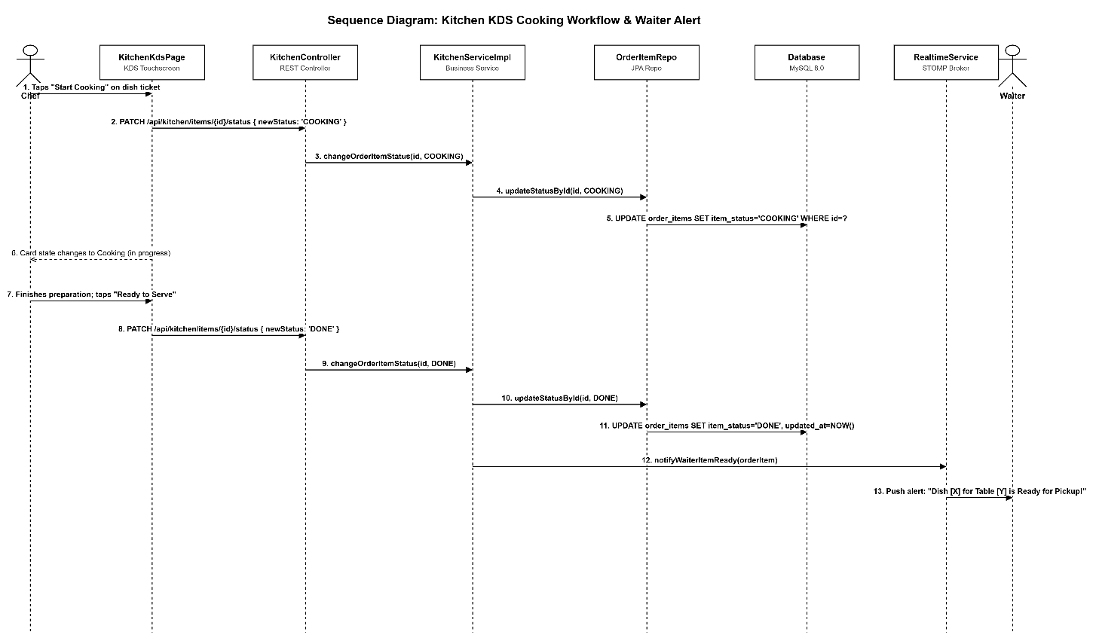
Figure 11: Sequence Diagram for Kitchen Cooking State Machine & Floor Alerts
Cooking State Transition Workflow:
- Step 1: Chef taps "Start Cooking" on a pending dish card on the KDS touchscreen.
- Step 2: Frontend sends PATCH /api/kitchen/items/{id}/status with newStatus = COOKING to KitchenController.
- Step 3: KitchenServiceImpl updates order_items.item_status to COOKING in MySQL database.
- Step 4: When dish preparation is finished, chef taps "Ready to Serve" button (DONE).
- Step 5: KitchenController receives status update request with newStatus = DONE.
- Step 6: KitchenServiceImpl persists DONE status with updated_at completion timestamp.
- Step 7: KitchenServiceImpl triggers RealtimeService.notifyWaiterItemReady() to push STOMP message to /topic/waiter.
- Step 8: Waiter handheld terminals receive push alert displaying: "Dish [Dish Name] for Table [Table No] is ready for serving".

d. Database Queries
-- 1. Query active kitchen tickets ordered chronologically (FIFO)
SELECT oi.id, oi.order_id, oi.quantity, oi.notes, oi.item_status, oi.created_at,
m.item_name, m.category_id, t.table_number, z.zone_name
FROM order_items oi
JOIN menu_items m ON oi.menu_item_id = m.id
JOIN orders o ON oi.order_id = o.id
JOIN dining_sessions ds ON o.dining_session_id = ds.id
JOIN restaurant_tables t ON ds.table_id = t.id
JOIN zones z ON t.zone_id = z.id
WHERE oi.item_status IN ('PENDING', 'COOKING')
ORDER BY oi.created_at ASC;

-- 2. Update dish status transition
UPDATE order_items
SET item_status = ?, updated_at = NOW()
WHERE id = ?;

5. Cashier Billing & Financial Settlement (Payment & PayOS)
This feature handles invoice aggregation, payment method execution (Cash or automated PayOS VietQR), webhook signature verification, table release, and dining session closure. The billing formula aggregates non-cancelled order items, applies optional discounts, and generates immutable fiscal records in the bills table.

a. Class Diagram
Billing and payment processing classes:
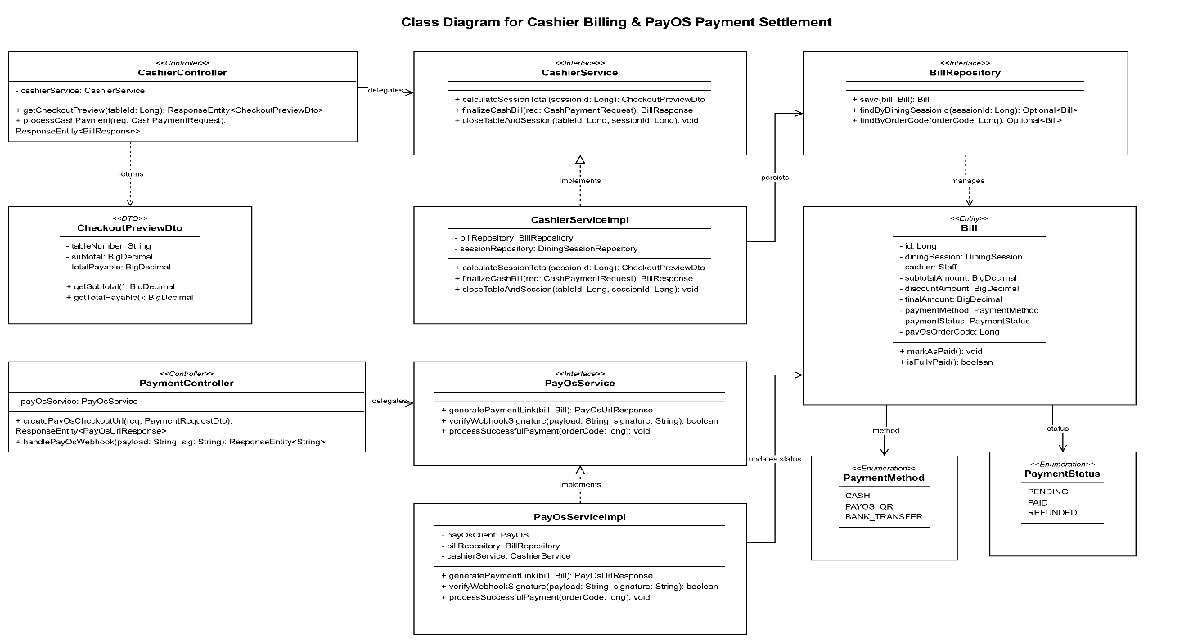
Figure 12: Class Diagram for Cashier Billing & PayOS Payment Settlement
- CashierController: Cashier POS endpoints for bill preview, discount application, and cash settlement.
- PaymentController: Payment gateway endpoints handling PayOS QR link creation and asynchronous webhooks.
- CashierServiceImpl: Executes bill calculation, invoice creation, and table status reset.
- PayOsServiceImpl: Integrates with PayOS Open API SDK for payment URL creation and HMAC-SHA256 signature verification.
- BillRepository: JPA repository persisting completed invoices and financial audit records.

b. Class Specifications

CashierController Class
Class Methods: CashierController
No | Method | Description
01 | getCheckoutPreview(@PathVariable Long tableId) | Input: Long tableId.  Output: ResponseEntity<ApiResponse<CheckoutPreviewDto>>.  Internal Processing: Invokes CashierService.calculateSessionTotal() -> returns line-item summary and final payable balance.
02 | processCashPayment(@RequestBody @Valid CashPaymentRequest req) | Input: CashPaymentRequest (tableId, cashReceived, discountAmount).  Output: ResponseEntity<ApiResponse<BillResponse>>.  Internal Processing: Finalizes bill, asserts cashReceived >= finalAmount, records change due, closes session, and frees table.

PaymentController & PayOsServiceImpl Classes
Class Methods: PaymentController & PayOsService
No | Method | Description
01 | createPayOsCheckoutUrl(@RequestBody PaymentRequestDto req) | Input: PaymentRequestDto (tableId).  Output: ResponseEntity<ApiResponse<PayOsPaymentUrlResponse>>.  Internal Processing: Aggregates bill amount -> calls PayOsService.generatePaymentLink() -> returns VietQR image URL.
02 | handlePayOsWebhook(@RequestBody String webhookPayload, @RequestHeader String signature) | Input: Raw webhook JSON body and HMAC signature header.  Output: ResponseEntity<String>.  Internal Processing: 1. Verifies HMAC-SHA256 checksum with secret key. 2. Extracts orderCode and status. 3. If PAID, marks bill as settled, closes session, and releases table. 4. Returns HTTP 200 OK.

c. Sequence Diagram(s)
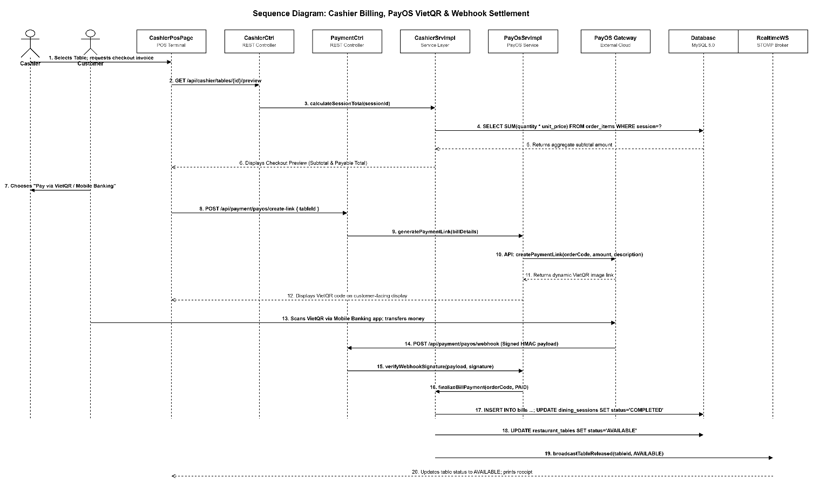
Figure 13: Sequence Diagram for Cashier Checkout & PayOS Online Payment Settlement
PayOS QR Payment & Webhook Settlement Sequence:
- Step 1: Cashier opens table checkout screen; frontend requests GET /api/cashier/tables/{id}/preview.
- Step 2: Customer chooses PayOS VietQR payment option; Cashier taps "Generate QR Code".
- Step 3: PaymentController delegates to PayOsServiceImpl.generatePaymentLink(billDetails).
- Step 4: PayOsService calls PayOS Cloud API using API Key and Client ID, receiving a dynamic VietQR payment link.
- Step 5: Cashier screen and customer phone display VietQR image with exact bill amount and description.
- Step 6: Customer scans QR code using any Vietnamese mobile banking app (MBBank, Vietcombank, etc.) and completes transfer.
- Step 7: PayOS servers detect instant bank transfer and dispatch signed POST webhook to ROMS server.
- Step 8: PaymentController verifies webhook HMAC-SHA256 checksum. Upon successful verification, updates Bill to PAID.
- Step 9: CashierServiceImpl updates dining_sessions.status = COMPLETED and restaurant_tables.status = AVAILABLE.
- Step 10: RealtimeService broadcasts table availability event to /topic/tables; POS UI updates immediately.

d. Database Queries
-- 1. Calculate final bill subtotal from all active orders
SELECT SUM(oi.quantity * oi.unit_price) AS subtotal
FROM order_items oi
JOIN orders o ON oi.order_id = o.id
WHERE o.dining_session_id = ? AND oi.item_status != 'CANCELLED';

-- 2. Insert invoice into bills table
INSERT INTO bills (dining_session_id, cashier_id, subtotal_amount, discount_amount, final_amount, payment_method, payment_status, created_at)
VALUES (?, ?, ?, ?, ?, ?, 'PAID', NOW());

-- 3. Close dining session
UPDATE dining_sessions
SET status = 'COMPLETED', checkout_time = NOW()
WHERE id = ?;

-- 4. Release table back to AVAILABLE state
UPDATE restaurant_tables
SET status = 'AVAILABLE'
WHERE id = ?;

6. Table Reservation Management (Booking & Buffer Allocation)
This feature enables patrons to reserve tables in advance through the public portal. The backend enforces a 90-minute conflict buffer window to prevent double-booking, manages deposit transactions, and provides administrative tools for table assignment and booking approval.

a. Class Diagram
Reservation subsystem classes:
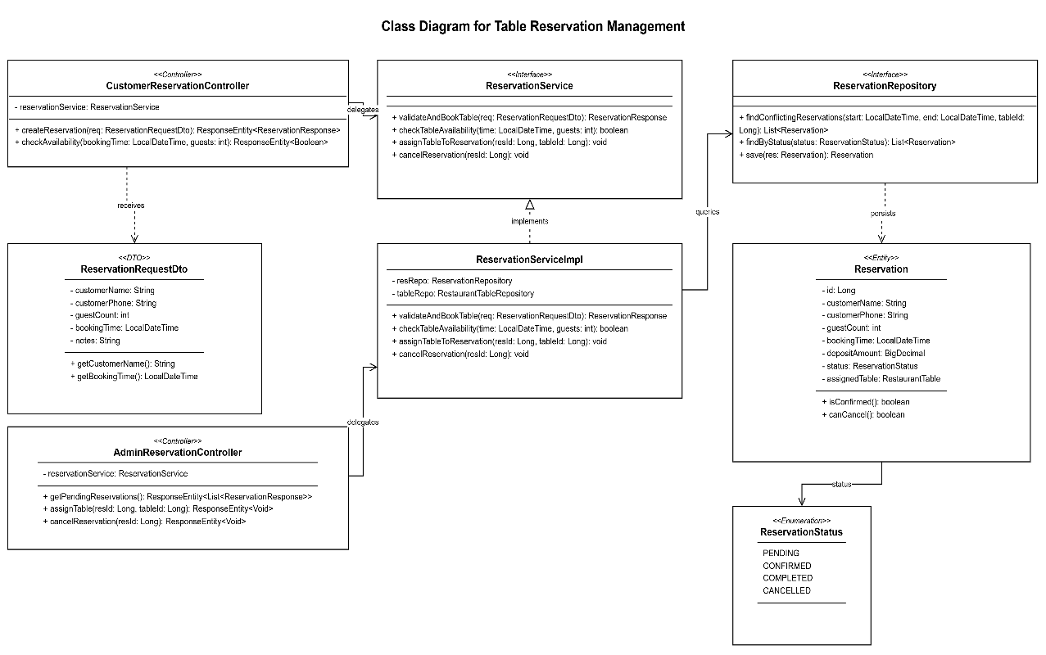
Figure 14: Class Diagram for Table Reservation Management
- CustomerReservationController: Customer-facing endpoints for creating advance booking requests.
- AdminReservationController: Manager endpoints for reviewing, approving, assigning tables, and cancelling bookings.
- ReservationServiceImpl: Business service validating capacity constraints, buffer window conflicts, and deposit requirements.
- ReservationRepository: JPA repository executing time-range overlap queries on reservation records.
- Reservation (Entity): Domain model representing reservation metadata, party size, appointment time, and status.

b. Class Specifications

CustomerReservationController & ReservationServiceImpl Classes
Class Methods: Reservation Management
No | Method | Description
01 | createReservation(@RequestBody @Valid ReservationRequestDto req) | Input: ReservationRequestDto (customerName, phone, guestCount, bookingTime, notes).  Output: ResponseEntity<ApiResponse<ReservationResponse>>.  Internal Processing: Validates guestCount > 0, bookingTime in future -> calls ReservationService.validateAndBookTable() -> returns booking confirmation.
02 | validateAndBookTable(ReservationRequestDto req) | Input: ReservationRequestDto.  Output: Reservation entity.  Internal Processing: 1. Evaluates table availability across 90-minute conflict window. 2. Selects suitable table matching party size. 3. Persists Reservation with status = PENDING. 4. Returns saved entity.
03 | assignTableToReservation(Long reservationId, Long tableId) | Input: Long reservationId, Long tableId.  Output: Reservation.  Internal Processing: Assigns physical table, updates status to CONFIRMED, marks table as RESERVED during buffer window.

c. Sequence Diagram(s)
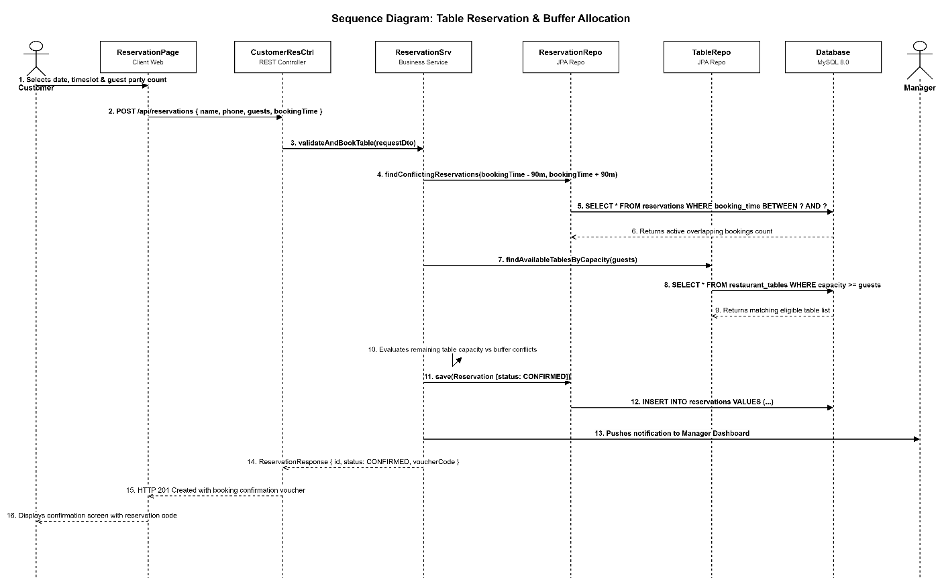
Figure 15: Sequence Diagram for Customer Table Booking & Reservation Confirmation
Reservation Booking & Conflict Prevention Sequence:
- Step 1: Customer selects date, timeslot, and number of guests on public reservation page.
- Step 2: Customer submits booking form; POST /api/reservations is dispatched to CustomerReservationController.
- Step 3: ReservationServiceImpl executes conflict detection query checking whether available tables exist with capacity >= guests without overlapping active reservations within +/- 90 minutes.
- Step 4: If conflicting bookings saturate capacity, service returns HTTP 409 Conflict with alternative timeslots.
- Step 5: If capacity is available, service persists Reservation with status = CONFIRMED.
- Step 6: System triggers email/SMS notification service to send confirmation voucher to customer.

d. Database Queries
-- 1. Check for overlapping reservations within 90-minute buffer window
SELECT r.id, r.table_id, r.booking_time, r.guest_count, r.status
FROM reservations r
WHERE r.table_id = ?
AND r.status IN ('PENDING', 'CONFIRMED')
AND r.booking_time BETWEEN DATE_SUB(?, INTERVAL 90 MINUTE)
AND DATE_ADD(?, INTERVAL 90 MINUTE);

-- 2. Insert new confirmed table reservation
INSERT INTO reservations (table_id, customer_name, customer_phone, guest_count, booking_time, deposit_amount, status, created_at)
VALUES (?, ?, ?, ?, ?, ?, 'CONFIRMED', NOW());

